**Exercises 2.10a**

**Installed CORS, bcrypt and express-validator via npm (git bash)**

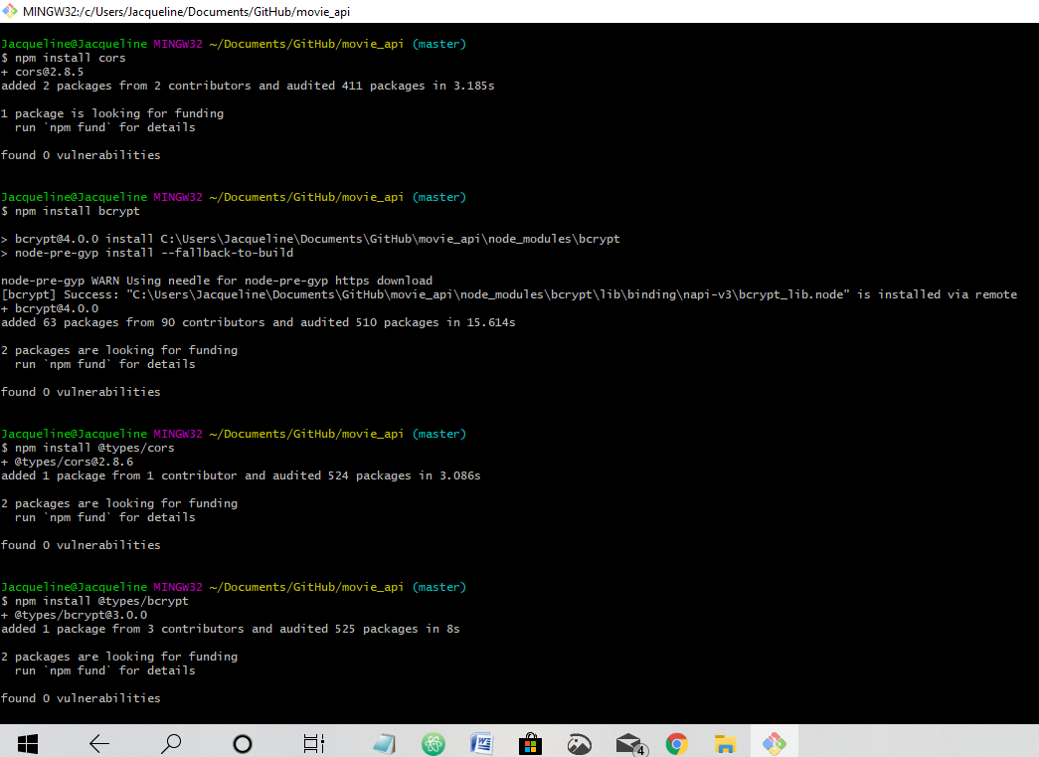

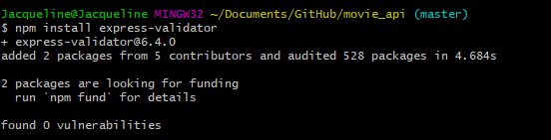

**Updated package.json:**

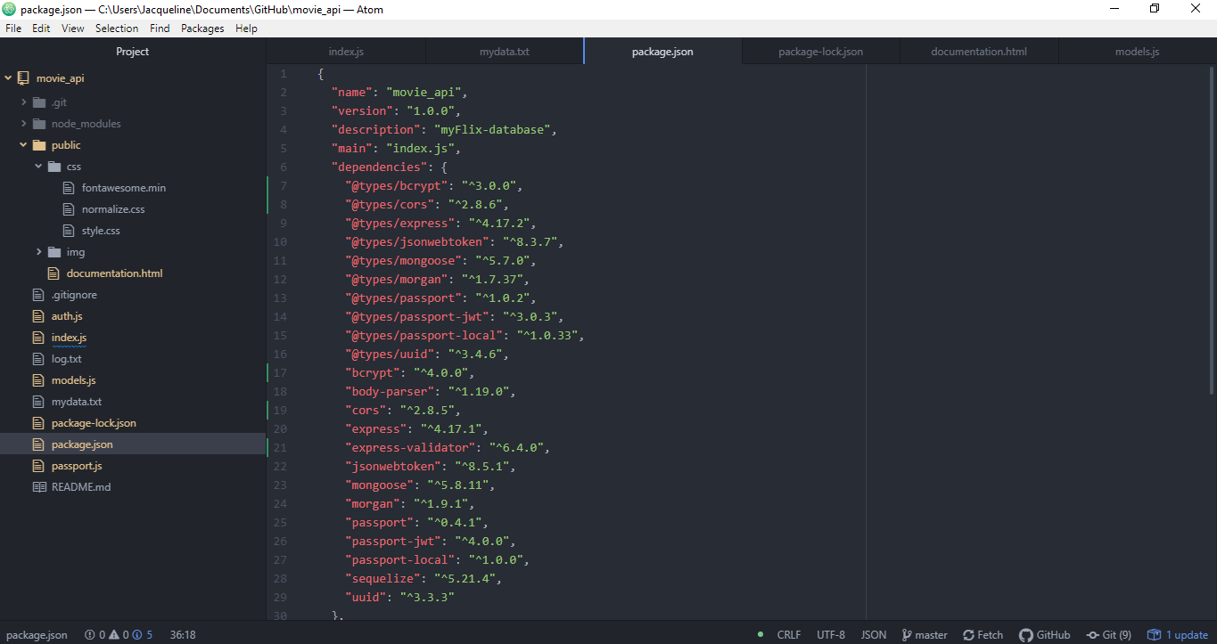

**Postman screenshots (testing code before deploying via Heroku and MongoDB Atlas)**

**New User Registration**

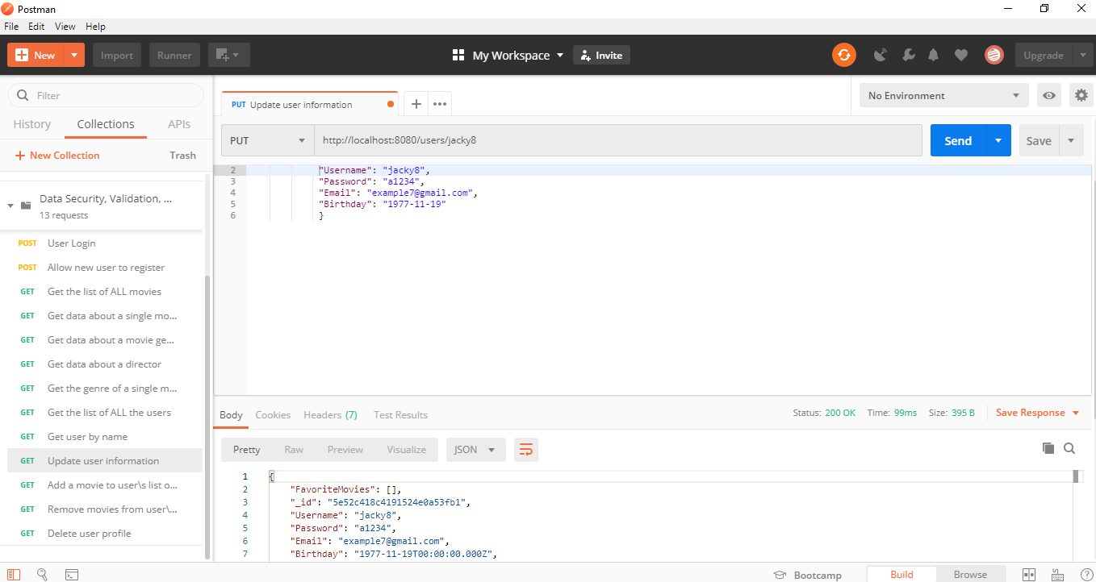

**New User login and authorization token**

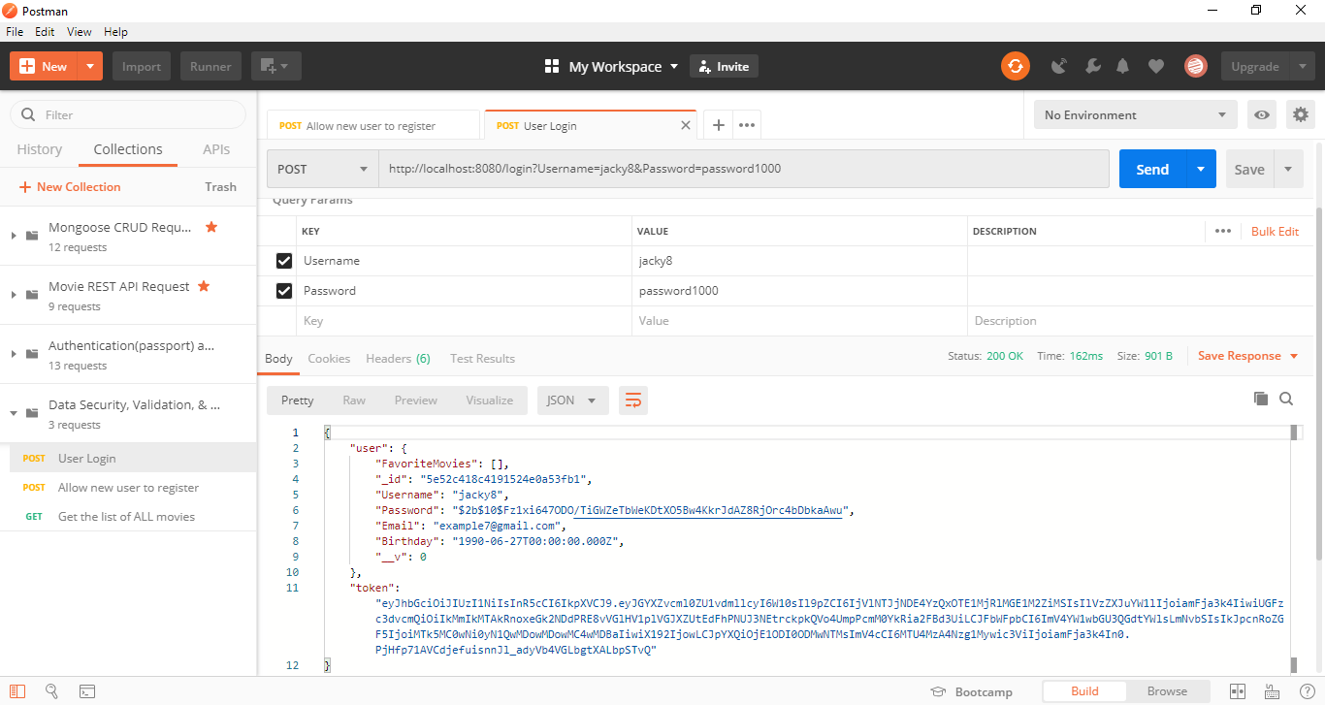

**Postman screenshots with authorization token (11 requests)**

**One: Return a list of ALL movies to the user:**

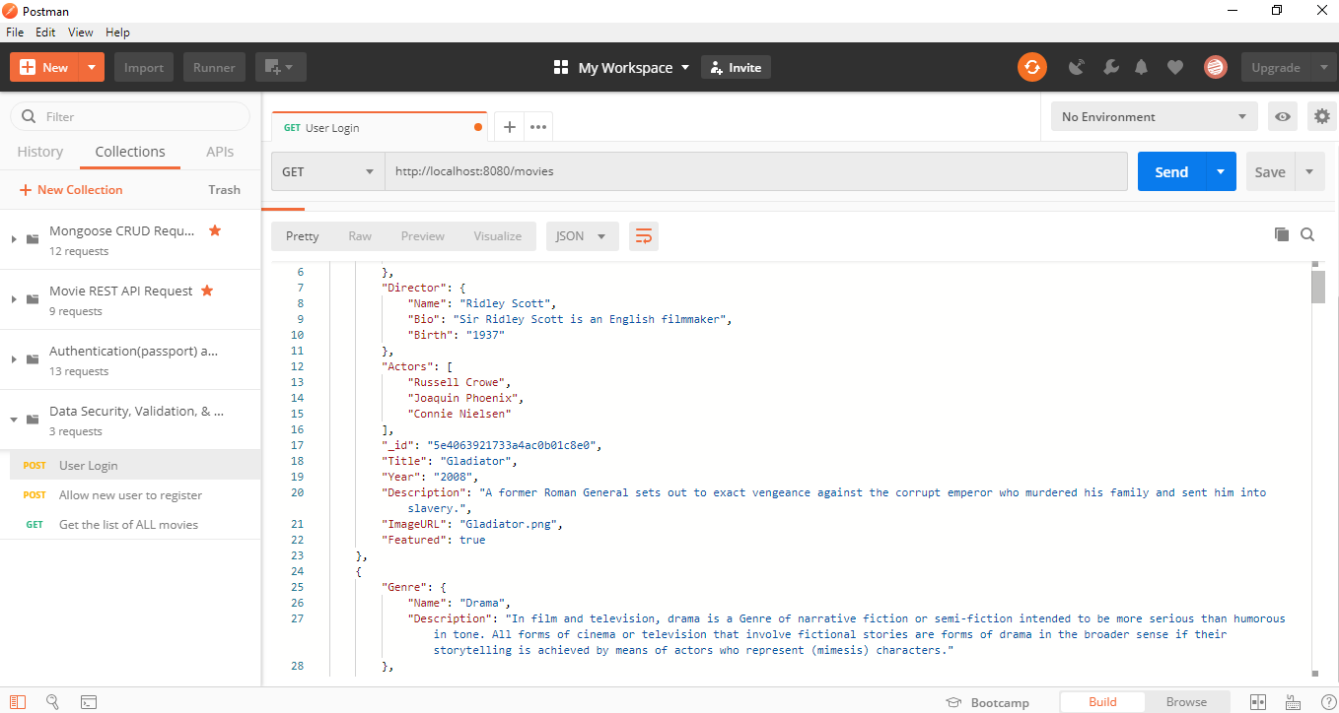

**Two: Return data (description, genre, director, image URL, whether it’s featured or not) about a single movie by title to the user:**

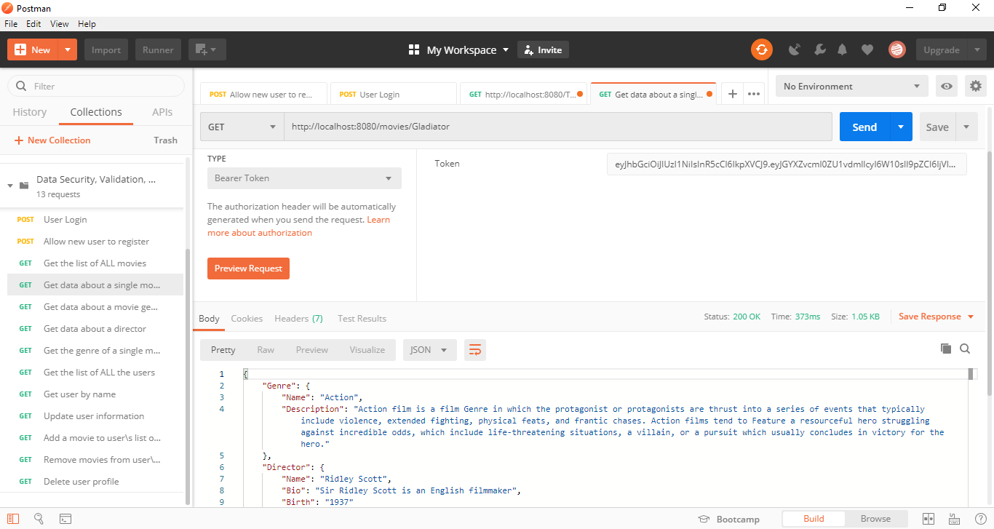

**Three: Return data about a genre by the movie title (e.g., “Gladiator”):**

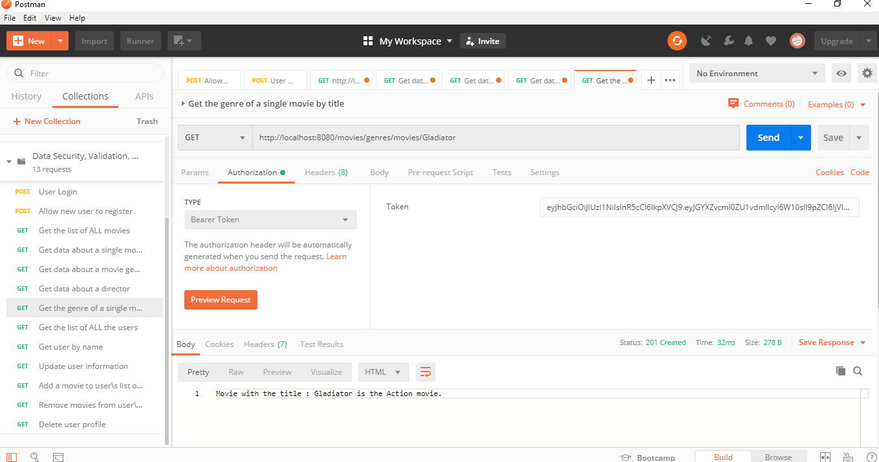

**Four: Return data about a genre (description) by the genre Name (e.g., “Drama”):**

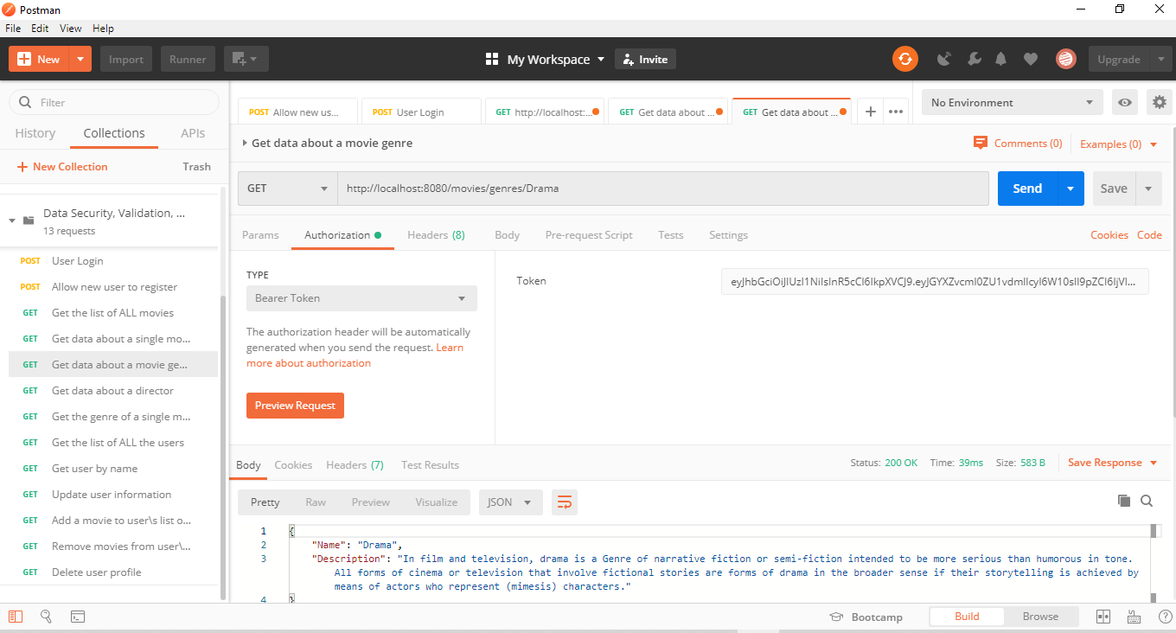

**Five: Return data about a director (bio, birth year, death year) by name:**

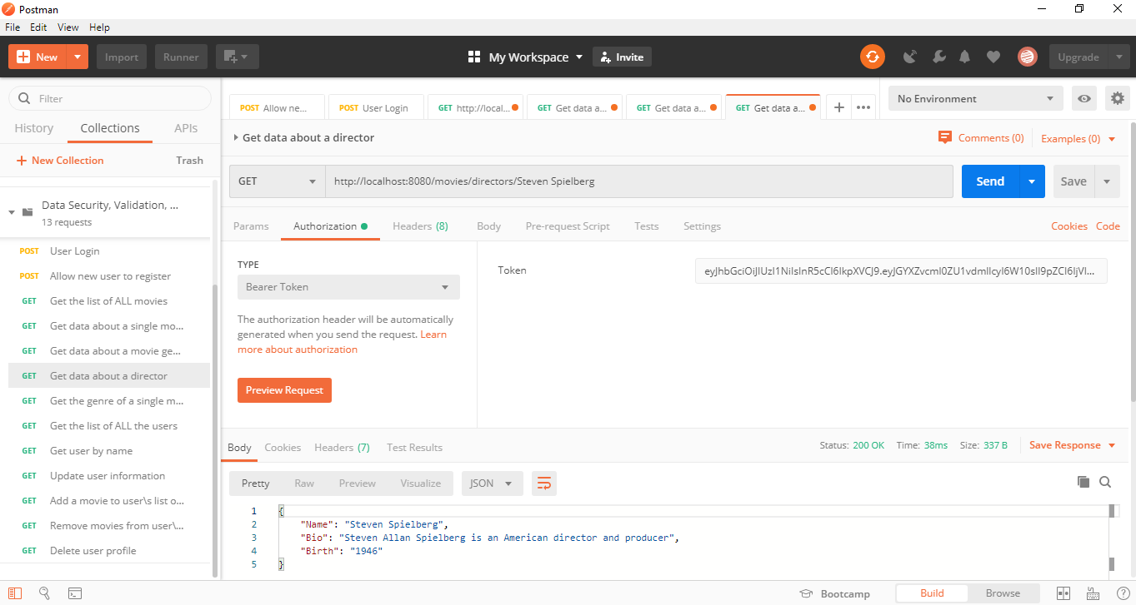

**Six: Return a list of ALL users:**

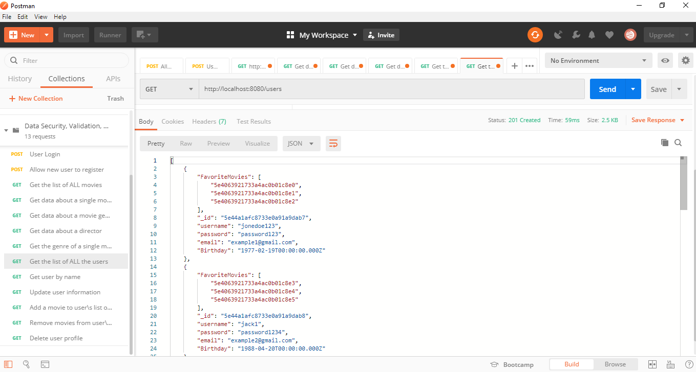

**Seven: Allow users to update their user info (username, password, email, date of birth):**



**Eight: Allow users to add a movie to their list of favorites:**

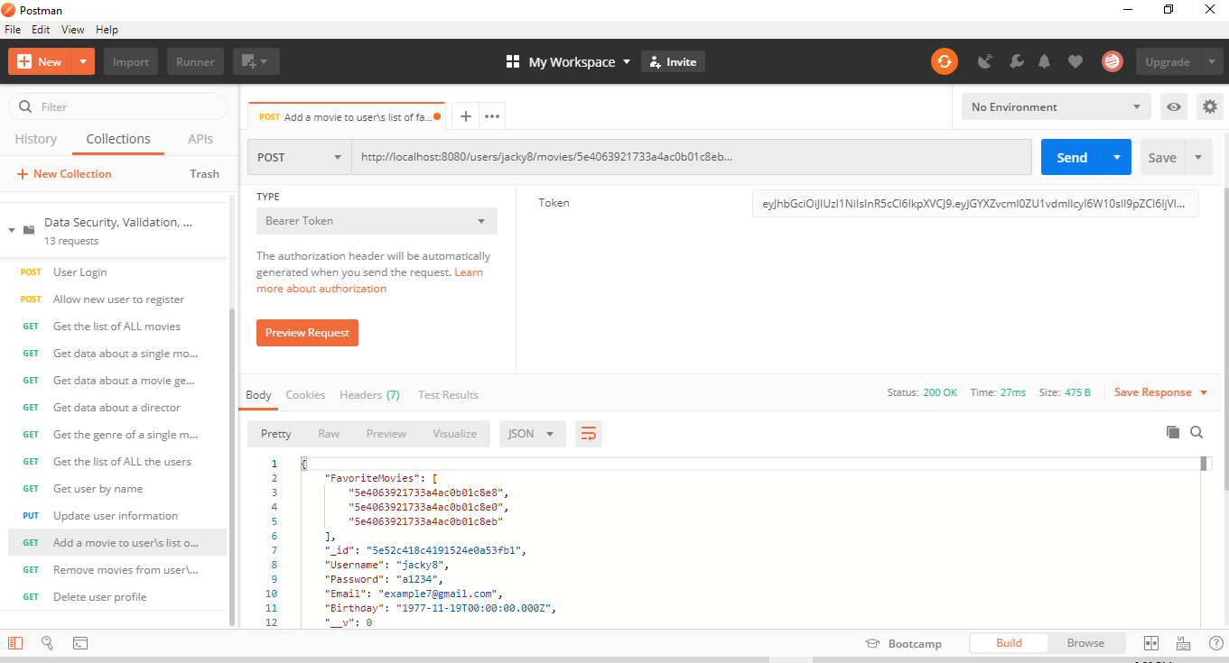

**Nine: Get user by Name:**

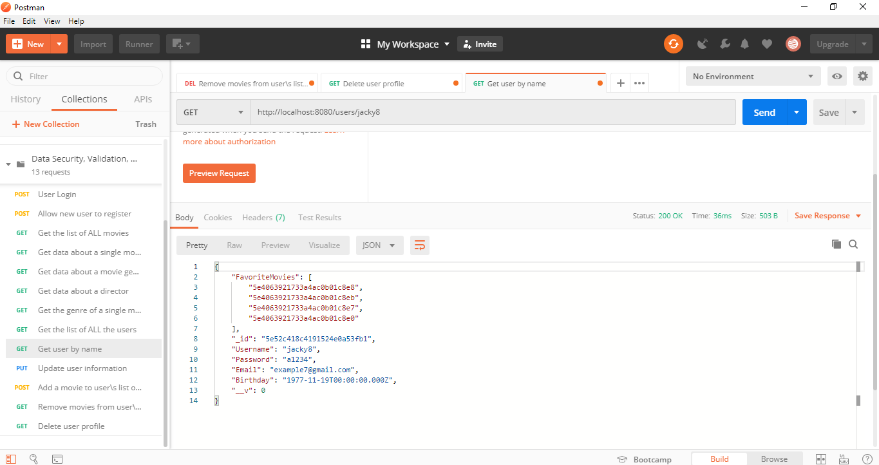

**Ten: Allow users to remove a movie from their list of favorites:**

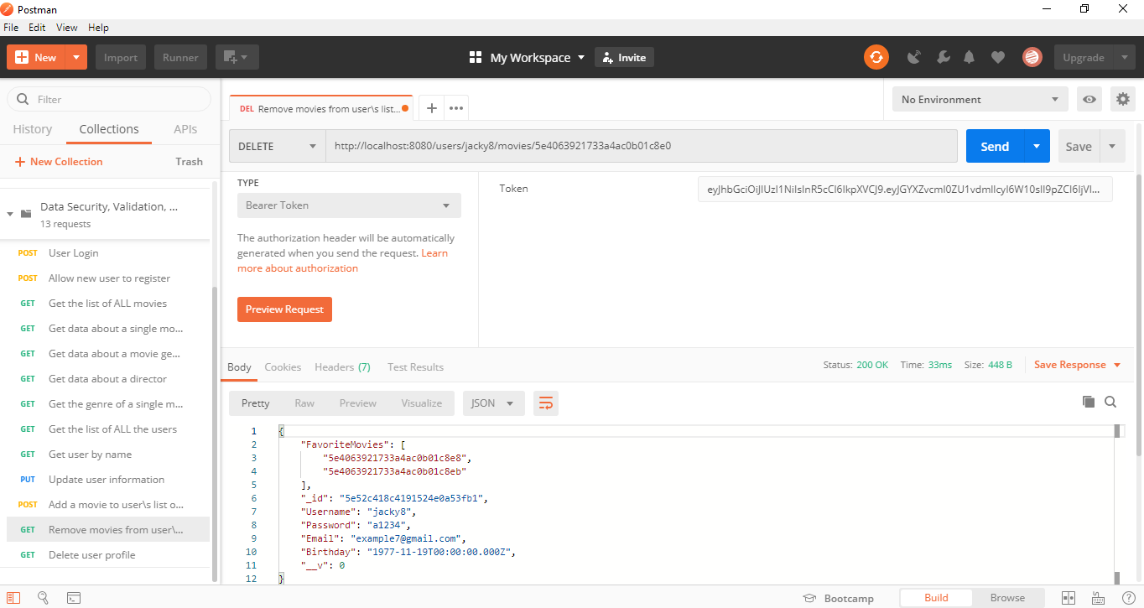

**Eleven: Allow existing users to deregister with authorization token:**

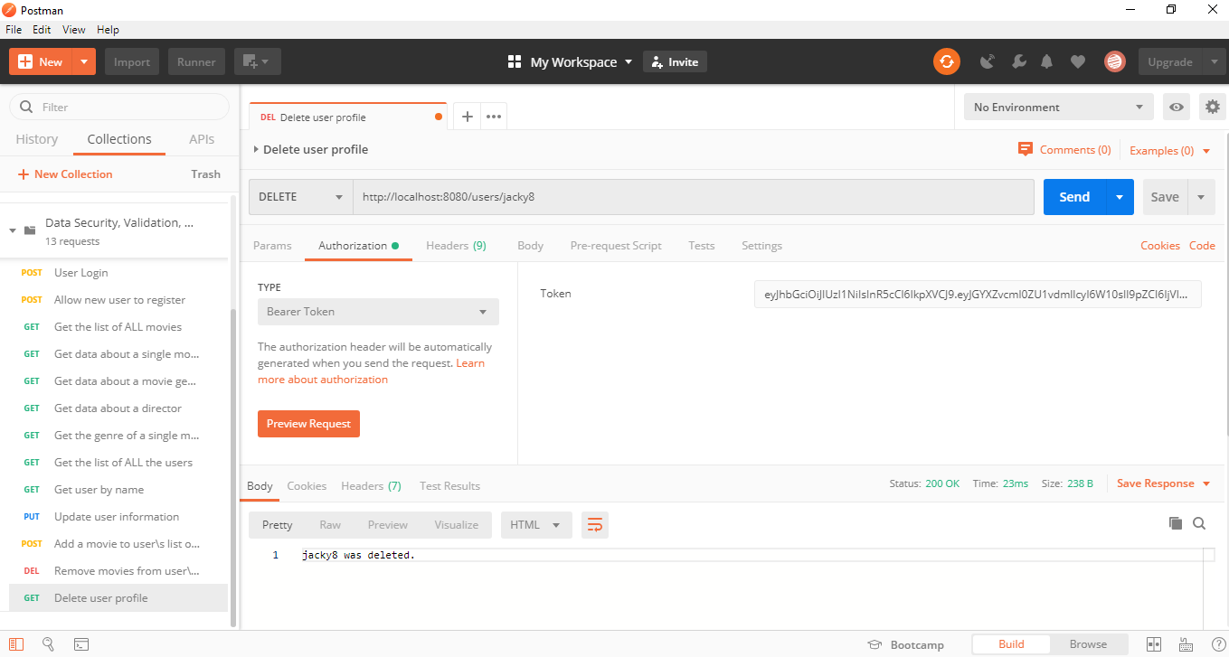

**Exercises 2.10b**

**Installed Heroku via command prompt:**

